Witch’s Rune (Traditional)
Darksome night and shining moon,
East, then South, then West, then North;
Hearken to the Witches' Rune
Here we come to call ye forth!
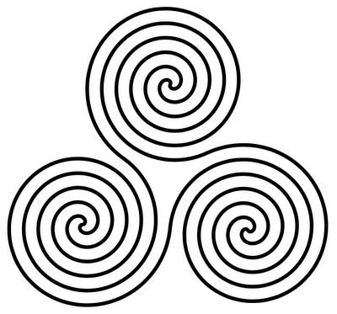
Earth and Water, Air and Fire,
Wand and Pentacle and Sword,
Work ye unto our desire,
Hearken ye unto our word!
Cords and censer, scrounge and knife,
Powers of the Witch's blade
Waken ye unto life,
Come ye as the charm is made!
Queen of heaven, Queen of hell,
Horned Hunter of the night
Lend your power unto the spell,
And work our will by magic rite!
By all the power of land and sea,
By all the might of moon and sun
As we do will, so mote it be;
Chant the spell, and be it done!

