Chakras and Auras
Chakra is a Sanskrit word translating into “Wheel.” The chakras are the major energy points along that body that are usually visualized as wheels or pin-wheels of light coming out from the body at these points. There are seven “main” chakras that fall along the spinal cord. These chakras are: root, sacral (hara), solar plexus, heart, throat, third eye (brow) and crown. Each of these chakras resonates at a certain frequency at which we can assign a color. Generally the chakras resonate in order of the colors in the rainbow (R.O.Y.G.B.I.V.). However some people practice a few variations as they may assign the color pink as an alternative to green or white/clear for violet. Chakras, from time to time, become unbalanced and may be classified as blocked, underactive, overactive or unbalanced. All of these can be seen through our actions and reactions as well as our mental, spiritual and emotional states.
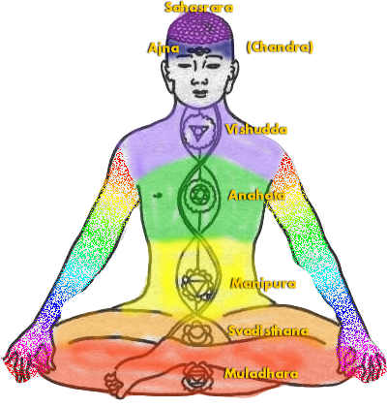
An aura is the energy field that surrounds the body. I like to be even more specific and say that the aura is simply a magnetic field that emits from the body and is formed through the energy of the chakras. Auras can range in a plethora of colors. Some people train themselves to see auras and we have even developed the invention of auric photography. When looking at the aura we are able to view the color and make generalizations about our state of being. Specific gifts can be noted through the color of an aura such as a natural healers emerald green aura or a mediums usual blue aura. Though we talk so much about seeing auras it is also important to realize that we can feel auras as well. The aura consists of four levels. The first level is the physical body. The second level is the mental body, running from the surface of the skin and 6 inches out. The third level is the emotional level, it sets 6-12 inches from the physical body. The last level is the spiritual body; containing all of our spiritual energy this field runs from 12 inches from the body out. The length of this field depends highly on the person’s spiritual practice. The contents here only skims the surface and if auras are something you are strongly considering you should definitely study deeper.

Aura Colors:
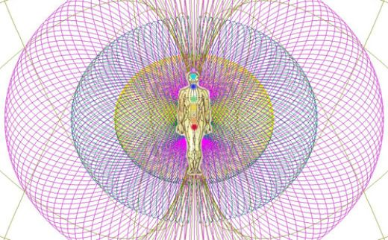
Purple: indicates spiritual thoughts. Purple is never a strong point in the Aura.
Blue: Balanced existence, sustaining life, eased nerve system, transmitting forces and energy. People with blue strong point in their Aura are relaxed, balanced and feel ready to live in a cave and survive. They are born survivors. Blue thought is a thought about relaxing the nerve system to achieve the balance of the mind or a thought about surviving. Electric blue can override any other color in the Aura, when the person is receiving and/or transmitting information in a telepathic communication.
Green: restful, modifying energy, natural healing ability. All natural healers should have it. People with a green strong point in their Auras are natural healers. The stronger the green Aura, the better the healer. They also love gardening and usually have a "green hand" - anything grows for them. Being in a presence of a person with a strong and green Aura is a very peaceful and restful experience. Green thought indicates a restful state and healing.
Yellow: joy, freedom, non-attachment, freeing or releasing vital forces. People who glow yellow are full of inner joy, very generous and not attached to anything. Yellow halo around the head: high spiritual development. A signature of a spiritual teacher. Yellow thought indicates a moment of joy and contentment.
Orange: uplifting and absorbing. Inspiring. A sign of power. Ability and/or desire to control people. Orange thought is a thought about exercising power or a desire to control people.
Red: materialistic thoughts, thoughts about the physical body. Predominantly red Aura indicates materialistically oriented person.
Pink: love (in a spiritual sense). To obtain a clean pink, you need to mix the purple (the highest frequency we perceive) with red (the lowest frequency). Pink Aura indicates that the person achieved a perfect balance between spiritual awareness and the material existence.
Brown: unsettling, distracting, materialistic, negating spirituality.
White: serious disease, artificial stimulation (drugs). Why does the white color in the Aura indicate problems? White color is like a noise, rather than a set of harmonious tones (monochromatic colors). It is impossible to "tune" the noise to an orchestra playing harmonious music, hence the white Aura indicates a lack of harmony in the body and mind. Nature, which we are a part of, is harmonious. This harmony comes in discrete vibration "tones" or harmonics, partially described by the modern quantum physics.
Several hours before the death, the Aura becomes white, and greatly increases in intensity. For this reason in most cultures "death" is depicted in WHITE (not black), because in the past, people could actually see a white Aura before death. It seems that our ancestors knew much more than we are prepared to admit.

Chakras
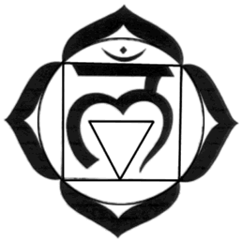
Root
Color: Red
Sanskrit Name: Muladhara
Location: Base of spine, coccyx
Lesson: Survival – The right to exist. Deals with tasks related to the material and physical world. Ability to stand up for oneself and security issues.
Imbalance: Anemia, fatigue, lower back pain, sciatica, depression. Frequent colds or cold hands and cold feet.
Stimulants: Physical exercise and restful sleeps, gardening, pottery and clay. Red food and drink. Red gemstones, red clothing, bathing in red, etc. Using red oils such as ylang ylang or sandalwood essential oils.
Sacral (spleen):
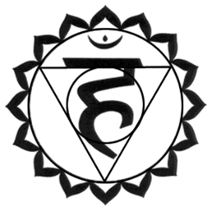
Color: Orange
Sanskrit Name: Svadisthana
Location: Below navel, lower abdomen
Lesson: Feelings – The right to feel. Connected to our sensing abilities and related feelings. Ability to be social and intimacy issues.
Imbalance: Eatins disorders. Alcohol and drug abuse. Depression. Low back pain. Asthma or allergies. Candida and yeast infections. Urinary problems. Sensuality issues as well as impotency and frigidity.
Stimulants: Hot aromatic baths, water aerobics, massage. Embracing sensations (such as different food tastes). Orange food and drink. Orange gemstones and orange clothing. Using orange oils such as Melissa or orange essential oils.

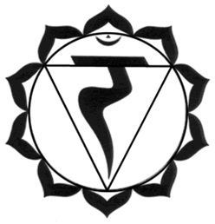
Solar Plexus:
Color: Yellow
Sanskrit Name: Manipura
Location: Above navel, stomach area
Lesson: Personal Power – The right to think. Balance of intellect, self-confidence and ego power. Ability to have self-control and humor.
Imbalance: Digestive problems, ulcers, diabetes, hypoglycemia, constipation. Nervousness, toxicity, parasites, colitis, poor memory.
Stimulants: Taking classes, reading informative books, doing mind puzzles. Sunshine. Detoxication programs. Yellow food and drinks. Yellow gemstones and yellow clothing. Using yellow oils such as lemon or rosemary essential oils.
Heart:
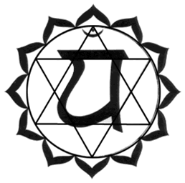
Color: Green/Pink
Sanskrit Name: Anahata
Location: Center of the chest
Lesson: Relationships – The right to love. Love, forgiveness, compassion. Ability to have self-control. Acceptance of oneself.
Imbalance: Heart and breathing disorders. Heart and breast cancer. Chest pain. High blood pressure. Passivity. Immune system problems. Muscular tension.
Stimulants: Nature walks, time spent with family or friends. Green/pink food and drink. Green/pink gemstones and green/pink clothing. Using green oils such as eucalyptus or pine essential oils.

Throat:
Color: Blue
Sanskrit Name: Viuddha
Location: Throat region
Lesson: Relationships – The right to speak. Learning to express oneself and one’s beliefs (truthful expression). Ability to trust. Loyalty. Organization and planning.
Imbalance: Thyroid imbalances, swollen glands. Fever and flu. Infections. Mouth, jaw, tongue, neck and shoulder problems. Hyperactivity. Hormonal disorders such as PMS, mood swings, bloating and menopause.
Stimulants: Singing (in the shower), poetry, stamp or art collecting. Meaningful conversations. Blue food and drink. Blue gemstones and blue clothing. Using blue oils such as chamomile or geranium essential oils.
Third Eye (Brow):
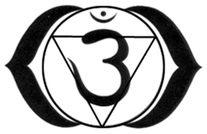
Color: Indigo/Violet
Sanskrit Name: Anja
Location: Forehead, in between the eyes
Lesson: Intuition – The right to “see.” Trusting one’s intuition and insights. Developing one’s psychic abilities. Self-realization. Releasing hidden and repressed negative thoughts.
Imbalance: Thyroid imbalances, swollen glands. Fevers and flu. Infections. Mouth, jaw, tongue, neck and shoulder problems. Hyperactivity. Hormonal disorders such as PMS, mood swings, bloating and menopause.
Stimulants: Star gazing. Meditation. Indigo/Violet food and drink. Indigo/violet gemstones and indigo/violet clothing. Using indigo oils such as patchouli or frankincense essential oils.

Crown:
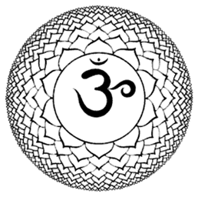
Color: Violet/White (Clear)
Sanskrit Name: Sahasrara
Location: Top of head
Lesson: Knowingness – The right to aspire. Dedication to the divine consciousness and trusting the universe. Learning about one’s spirituality. Our connection to the concept of “God” or a higher intelligence. Intergrating one’s consciousness and subconsciousness into the superconsciousness.
Imbalance: Headaches. Photosensitivity. Mental illnesses. Neuralgia. Senility. Right/left brain disorders and coordination problems. Epilepsy. Varicose veins and blood vessel problems. Skin rashes.
Stimulants: Focusing on dreams. Writing down one’s visions and inventions. Violet food and drink. Violet gemstones and violet clothing. Using violet oils such as lavender or jasmine essential oils.

